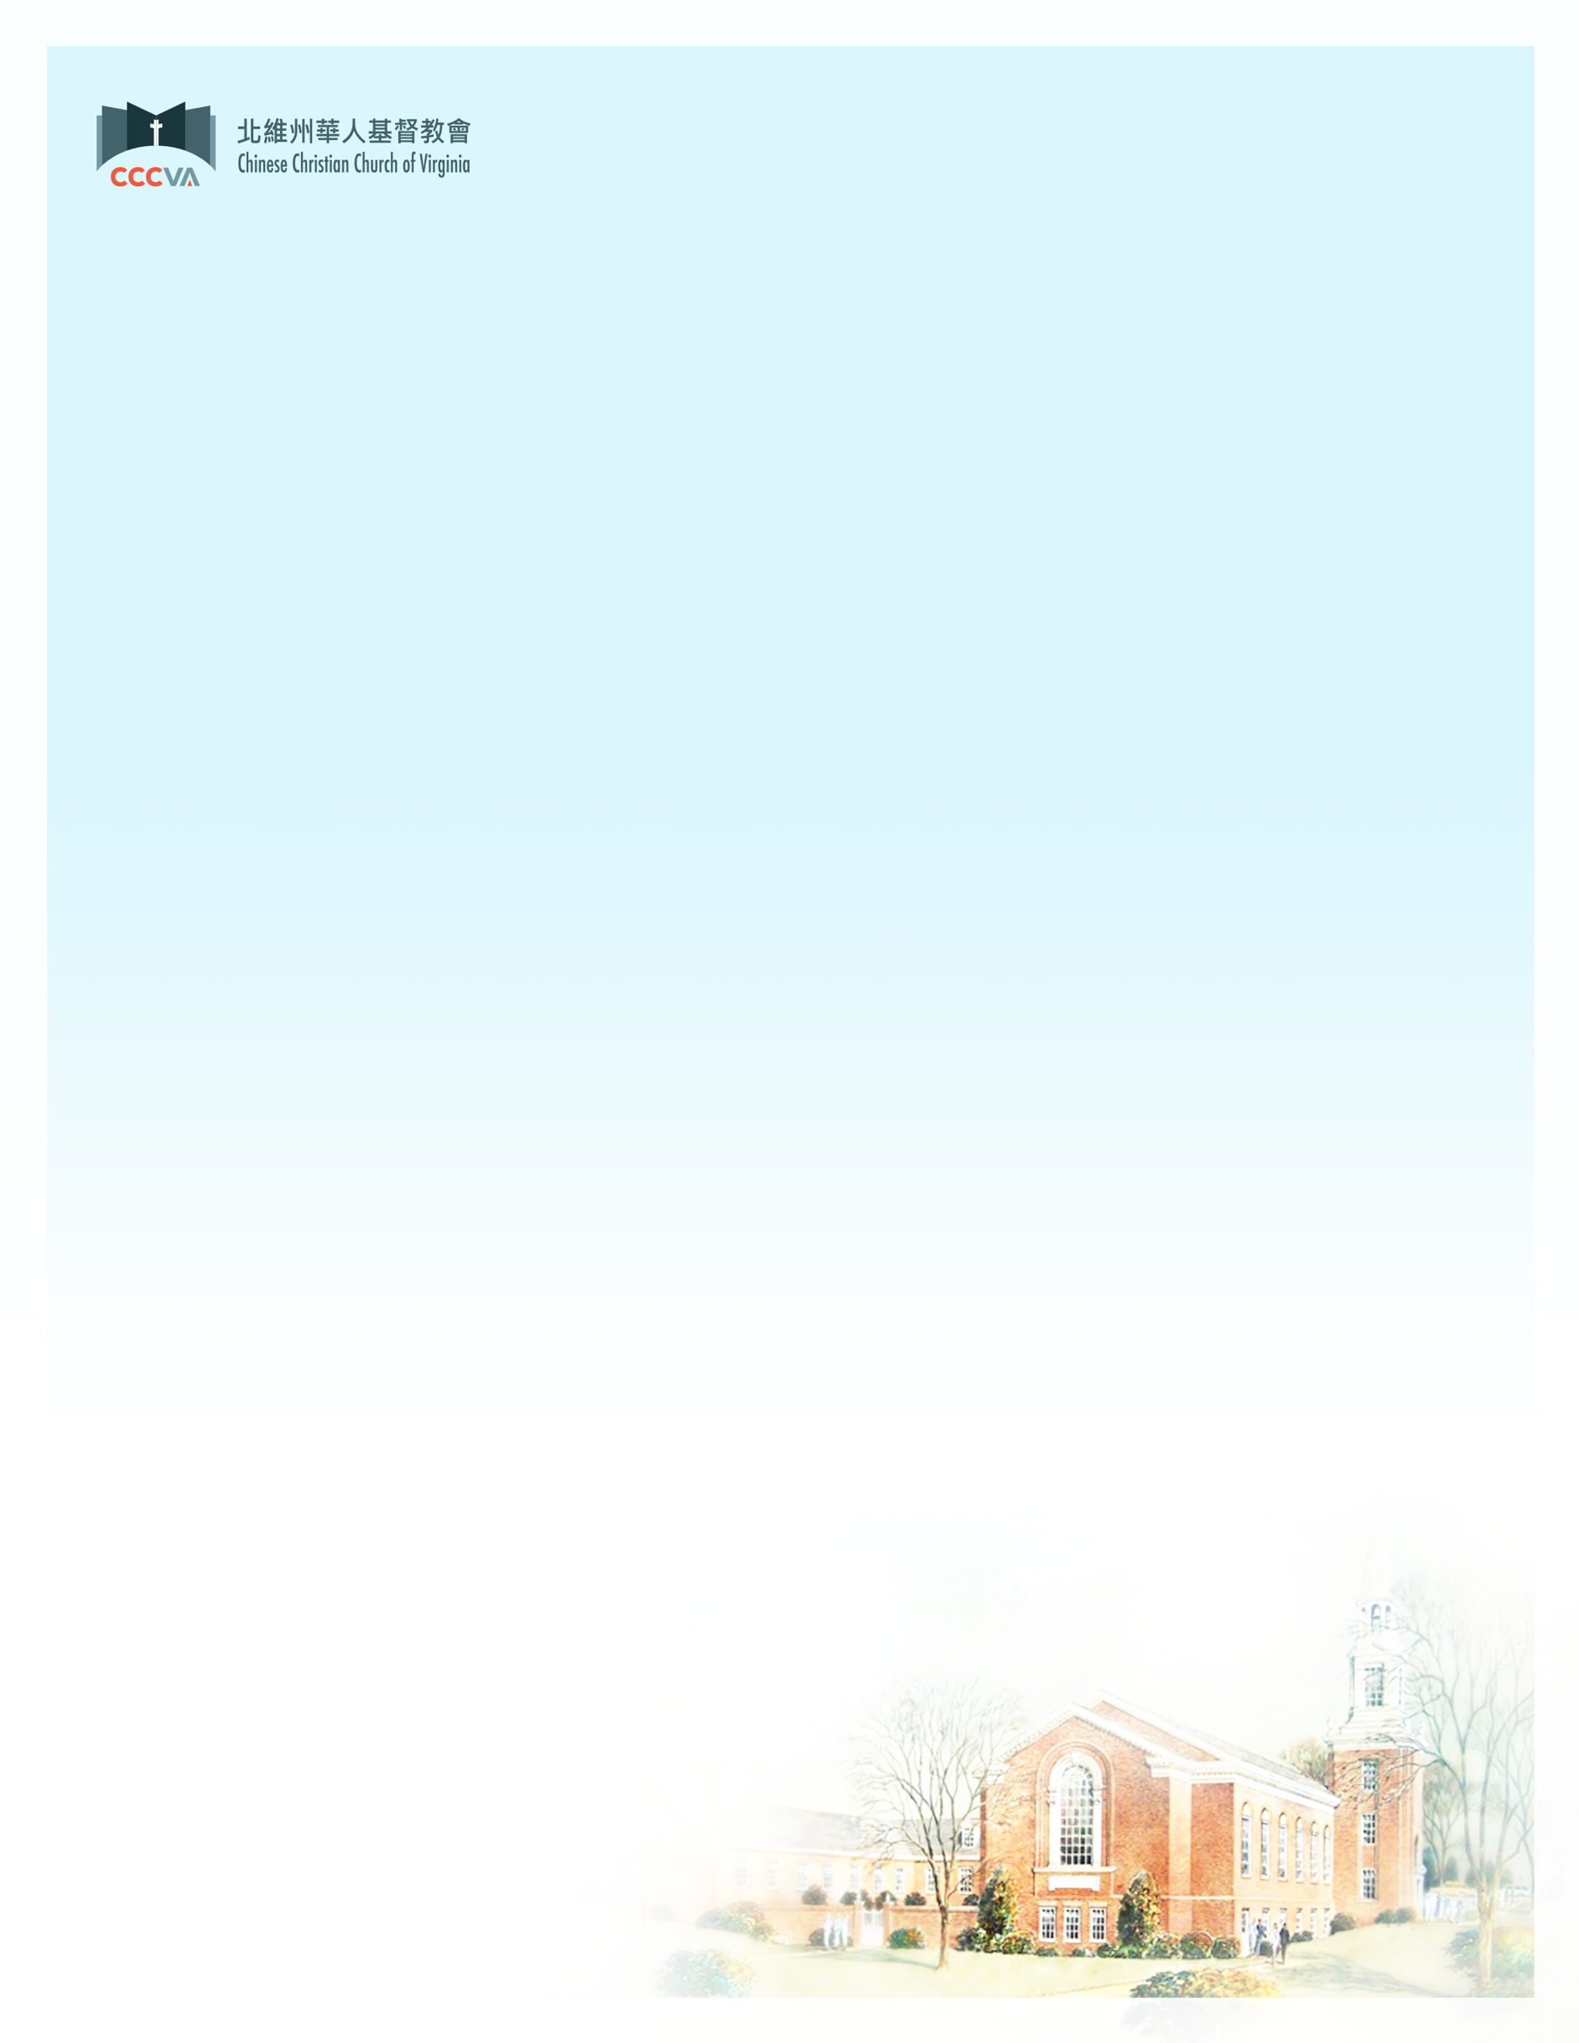

向主獻上感恩 Give Thanks to the Lord

「耶和華－我們的神啊，我們預備這許多材料，要為祢的聖名建造殿宇，都是從祢而來，都是屬祢的。我的神啊，我知道祢察驗人心，喜悅正直；我以正直的心樂意獻上這一切物。現在我喜歡看見祢的百姓在這裡都樂意奉獻與祢。 」【歷代志上29:16-17】

**“O LORD our God, as for all this abundance that we have provided for building you a temple for your Holy Name, it comes from your hand, and all of it belongs to you. I know, my God, that you test the heart and are pleased with integrity. All these things I have given willingly and with honest intent. And now I have seen with joy how willingly your people who are here have given to you.” ~ 1 Chronicles 29:16-17**

_______________________________________________

從大衛獻殿的禱告中，讓我們看見大衛因自己和百姓能樂意奉獻而「大大歡喜」（歷代志上29:9-14）。他之所以能如此樂意奉獻，是因為承認自己所有的都是神所賜下的恩典（申命記8:17-18），認識「萬物都從你而來，我們把從你而得的獻給你」（歷代志上29:14），所以沒有什麼可誇的。另外，大衛的禱告也提醒被擄回歸的百姓：不要被地上所見的環境所影響，因為即使是大衛王朝的黃金時代，也和其它世代一樣都不能永遠長存，唯有大衛所信靠的神和衪的國度才有「長存的指望」。我們所看見的世界和人都會改變，我們對這世界的未來也都沒有把握， 但我們信心的對象乃是我們的救主耶穌基督，聖經上說：「耶穌基督，昨日今日一直到永遠是一樣的。」（希伯來書13:8）

有件事值得一提，教會從2017年就開始啟動建堂計畫，從建築概念、設計、聽證會、會員大會，到去年最終完成的設計圖，一直到今年，已經將近八年的時間。在過去八年我們雖然經歴各種的艱難，但神是信實的，也一直感動弟兄姊妹繼續參與建堂的事工，除了2020年的疫情，每年我們都順利達到籌款目標。我們感謝天父的看顧與引導，也再此衷心地感謝弟兄姊妹為建堂的奉獻。在新的一年裡，願神用祂的愛和真理充滿我們，求主復興祂的教會，讓我們都在祂的恩典中不斷成長。

We see in David’s prayer for the building of the temple that his heart “rejoiced greatly” (1 Chronicles 29:9-14) because he and the people had given freely and wholeheartedly. The reason he could give freely was because he knew everything he owned is from the gracious hand of the LORD (Deuteronomy 8:17-18). David did not boast but acknowledged “everything comes from you, and we have given you only what comes from your hand.” (1 Chronicles 29:14) His prayer also served as a reminder to the captives returned from the exile not to be swayed by what was happening in the world, because even David’s kingdom at its peak was like all others which cannot stand forever. Only God whom David trusts and His Kingdom are our everlasting hope. The world and the people are ever-changing and we do not know what the future holds, but the Bible tells us “Jesus Christ is the same yesterday and today and forever” (Hebrews 13:8) therefore we can put our trust in our Lord and Savior Jesus Christ.

One thing worth mentioning is that it has been nearly 8 years since the Building Project started in 2017 and we have gone through the high-level design, detailed design, public hearings, congregational meetings, to reach the final design last year. Although we encountered all kinds of obstacles and difficulties in the past 8 years yet God is faithful. He continues to move brothers and sisters to remain committed to the Building Project and has helped us meet our fundraising goals every year except for 2020 due to the pandemic. We give thanks to our Father for His guidance and are grateful for everyone’s offering for this project. May God fill us abundantly with His love and truth, may God revive His Church, and may all of us continue to grow in His grace in the new year.

以馬內利 Emmanuel，

蔡明恩牧Pastor John Chua

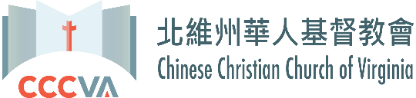

# 2025年建堂事工認獻表格Building Project Pledge Form

# ~募款目標Fundraising Goal: $四十七萬五千 $475,000~

感謝神的恩典及我/我們對神的信心,我/我們願意承諾以下的金錢奉獻:

By God’s grace and my/our trust in Him, I/we pledge the following monetary contributions:

(建議額數 Suggested amounts)

_____ $一萬 $10,000 _____ $四仟 $4,000

_____ $六仟 $6,000 _____ $三仟 $3,000

_____ $五仟 $5,000 _____ 其他額數 other amount: $________

我/我們將奉獻我/我們的金錢承諾 I/we will make my/our contributions:

_____ 每週一次 weekly ______ 一次全額獻上 one time

_____ 每月一次 monthly ______ 其他次數, 請註明大約日期

_____ 每季一次 quarterly others (please indicate approximate date(s)

姓名 Name : __________________________________________________________

住址 Address: __________________________________________________________

__________________________________________________________

電話 Phone: __________________________________________________________

日期 Date: __________________________________________________________

電郵住址 Email: __________________________________________________________

簽名 Signature(s): __________________________________________________________

認獻表格可寄至教會並在信封上標明"建堂認獻"或電郵給鄭文杰執事

Please send Pledge Form to CCCVA, Attention: CBP Pledge or email to <wenjie.zheng@gmail.com>

支票抬頭: CCCVA (備註建堂基金) Please make checks payable to CCCVA(memo Building Funds)

教會地址 church address: 6071 Leesburg Pike, Falls Church, VA 22041

電話 Phone: (703) 820-1010 傳真 Fax: (703) 820-1174

PayPal: [cccvapca.org/church_building/#fundraising](https://cccvapca.org/church_building/#fundraising)

教會網址 church website: cccvapca.org

謝謝你/你們對神的忠心和承諾,願神大大賜福你/你們!

Thank you for your commitment and pledge; may the Lord richly bless you!

北維州華人基督教會建堂委員會

The Chinese Christian Church of Virginia Building Project Committee